Here I have a dataset called video games sales dataset and it has attributes like

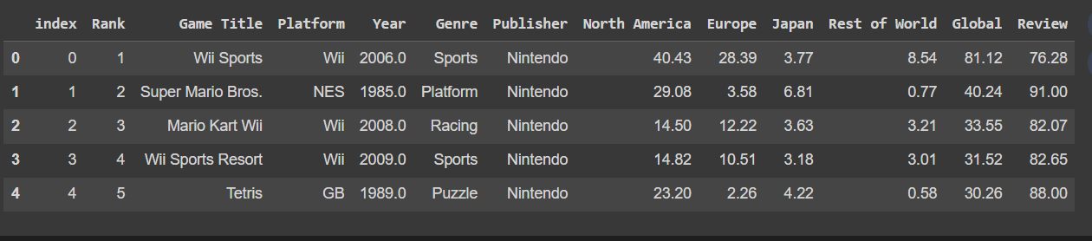

After the preprocessing :

Analysis on video games sales dataset :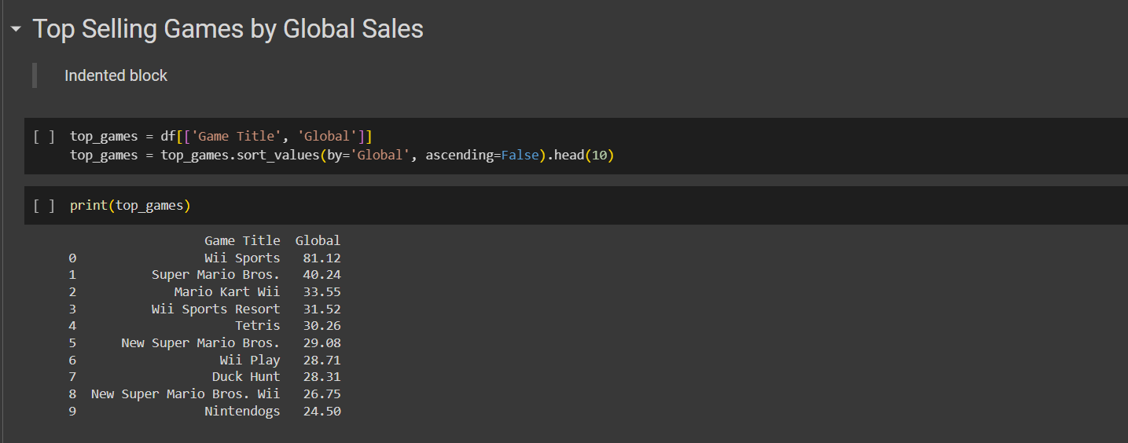

In this analysis we can identify the games that have achieved the highest global sales, representing the most successful titles in the dataset.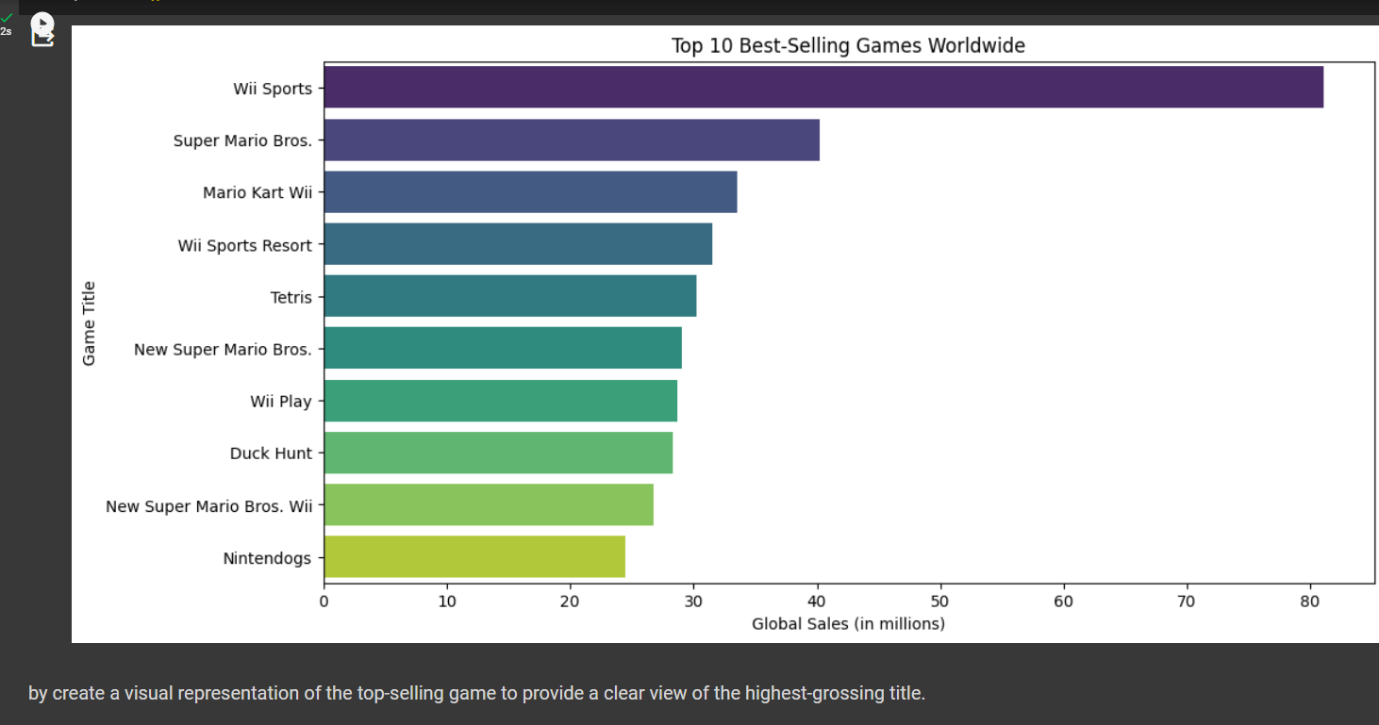

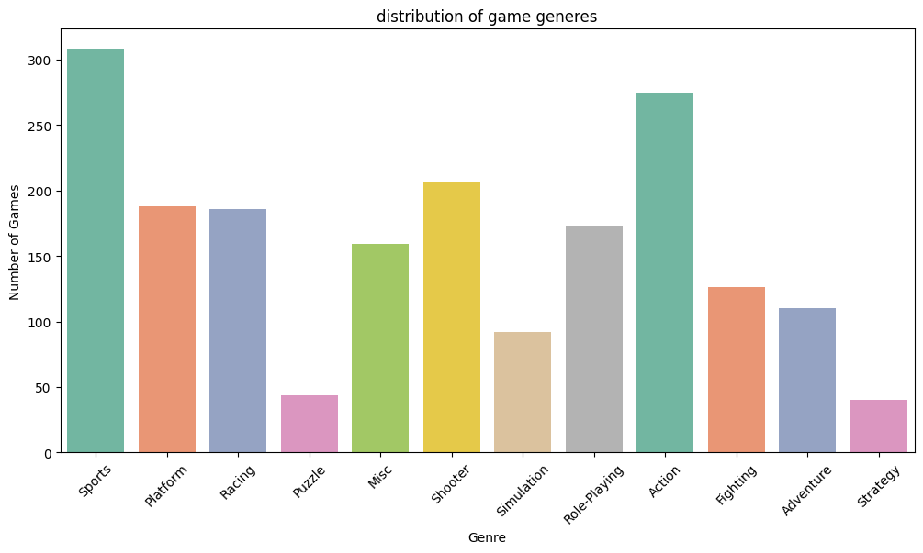

Visualizing how games are distributed across different genres to gain insights into the variety of gaming experiences available.

